**SRF WAREHOUSE 8106 FUNCTIONALITY**

**User’s Manual**

1. **After the approval of IMPEX in SRF, user must go to SRF Warehouse Receiving Entry (SERVICE REPAIR > TRANSACTIONS > Warehouse Receiving Entry) to check if the delivery is arrived and checking down the items for delivery.**

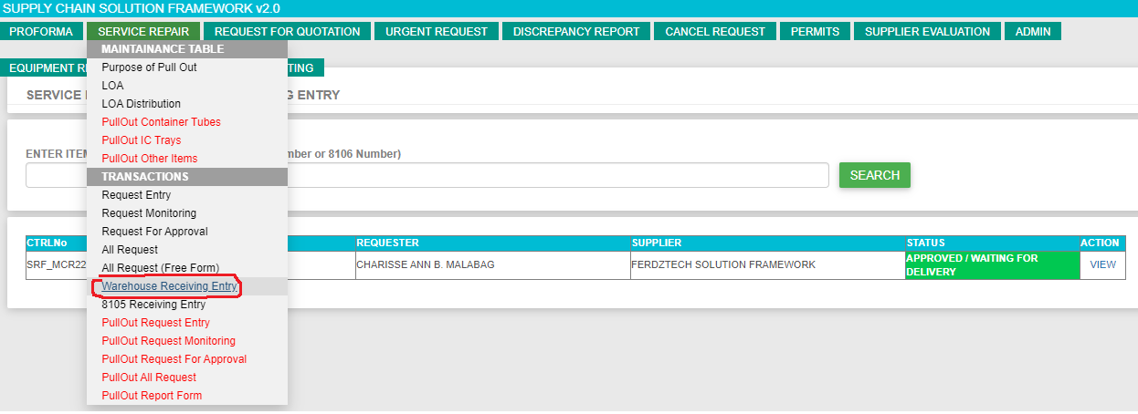

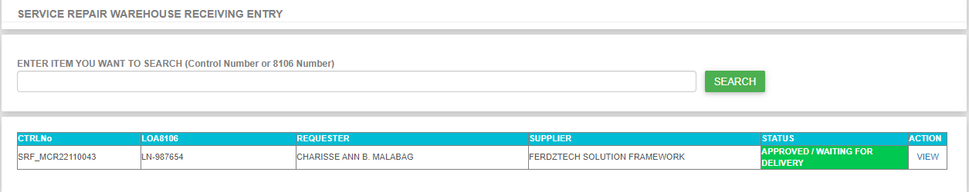

1. **By default, the status is APPROVED / WAITING FOR DELIVERY, once the user double click the VIEW link in ACTION column it will display the request details.**

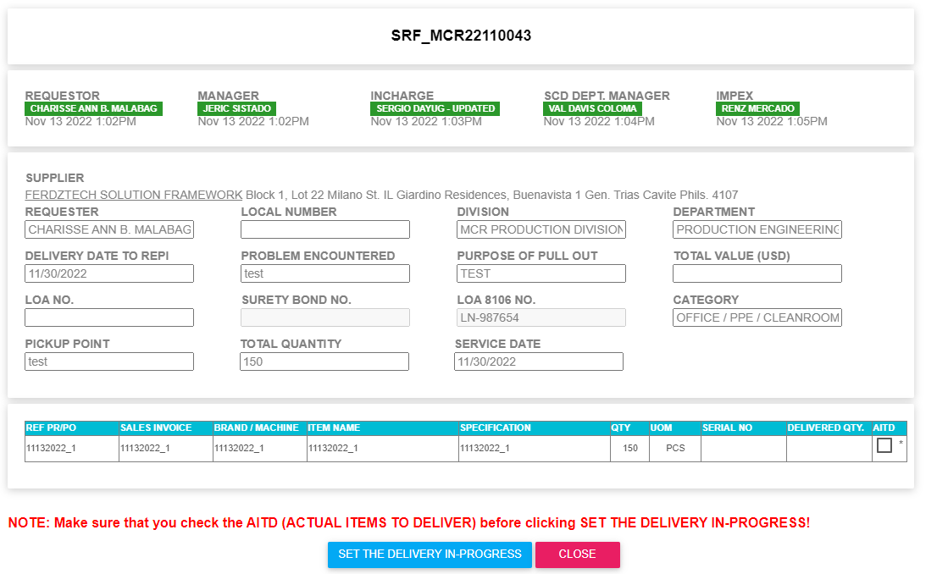

1. If delivery arrived at REPI, the user need to click the SET THE DELIVERY IN-PROGRESS to inform IMPEX through email that there is on-going delivery. Select the AITD or the ACTUAL ITEMS TO DELIVER before clicking the SET THE DELIVERY IN-PROGRESS.
2. After clicking the SET THE DELIVERY IN PROGRESS, IMPEX should received an email regarding the item details.



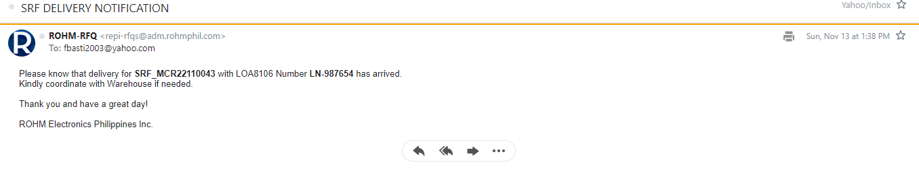

1. Confirmation message is being displayed after the setting the delivery in progress. There are 2 kinds of message confirmation. First is saying that it has been successfully move to delivery in-progress and impex has been notified. The second one is it has been successfully move to delivery in-progress and failed to notified impex due to connection issues.

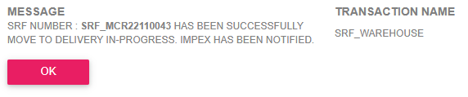

1. Status will change to DELIVERY IN-PROGRESS and item(s) to received is also displayed for monitoring purposes.

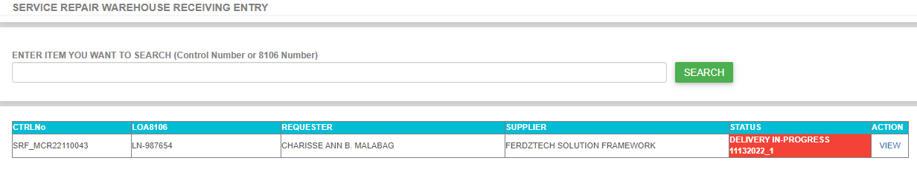

1. Once start receiving the item, double click the VIEW link to display the details and actual delivery.

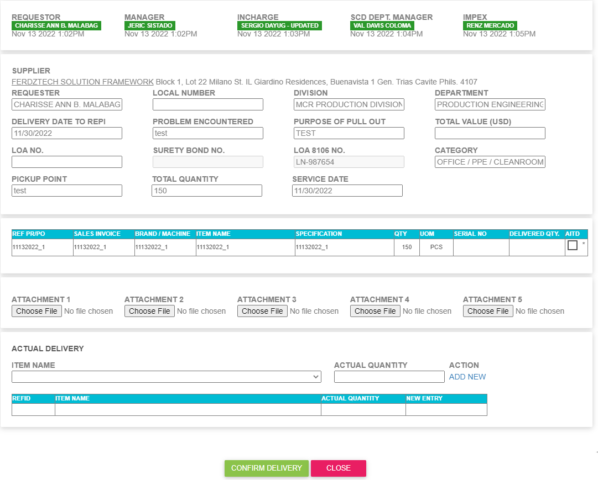

1. Select the actual item that is being drop or deliver by selecting ITEM NAME dropdown menu then enter the actual quantity before clicking the ADD NEW link then click the **CONFIRM DELIVERY.** Make sure the you not forget the **attachment** file.

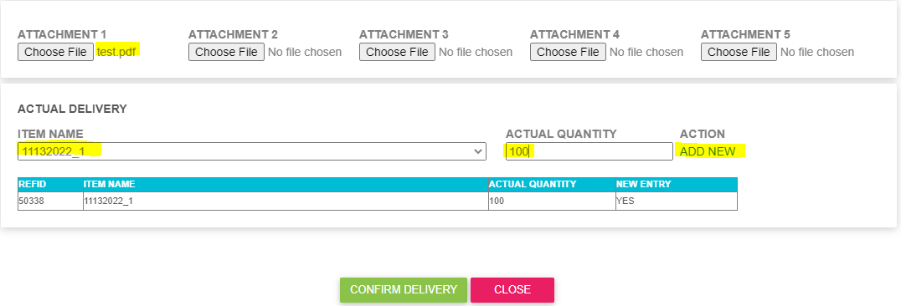

1. Again you will received confirmation that the delivery has been successfully process. Impex has been notified.

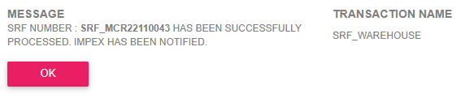

1. Impex will received and email regarding this actual delivery items.



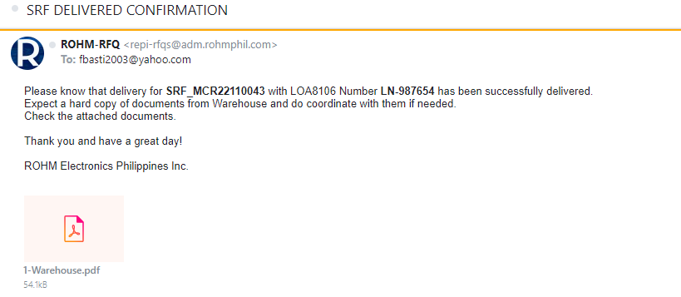

1. In our example we have 150PCS ordered items and the first delivery is 100PCS. When you go back to Warehouse Receiving Entry you will notice that the status of the request is DELIVERED WITH PENDING ITEMS.

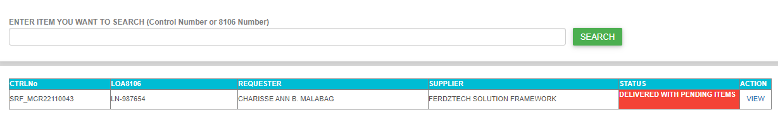

1. Next step is go to 8105 Receiving Entry. SERVICE REPAIR > 8105 Receiving Entry. The highlighted in yellow is our testing item. Double click the VIEW link in ACTION column to display the details.

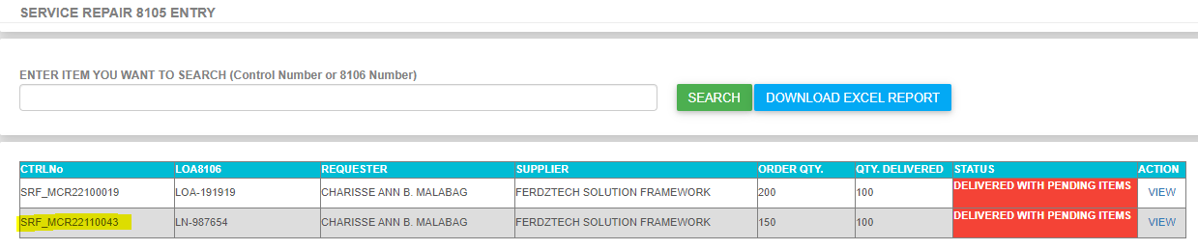

1. Make sure that you have entered the **LOA8106** and fill the **attachment** file before clicking submit button. Please see highlighted in yellow.

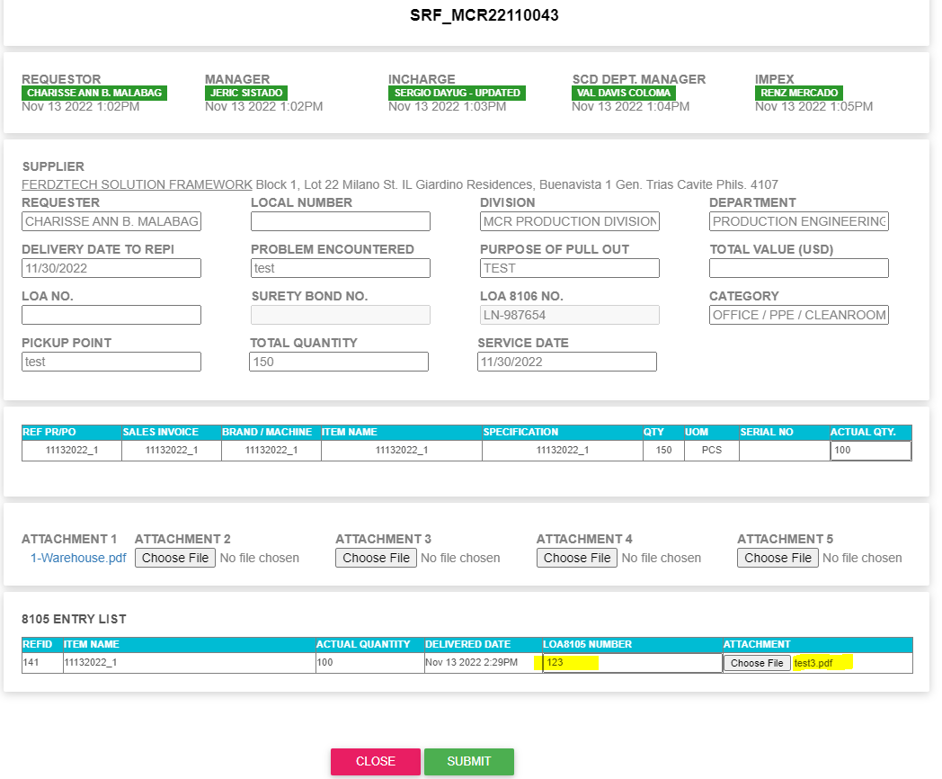

1. Confirmation will appear saying that 8105 is successfully added to specific SRF request or this transaction is liquidated. After clicking the OK button it will return to 8105 Receiving Entry but the item is gone in there because it was already liquidated.

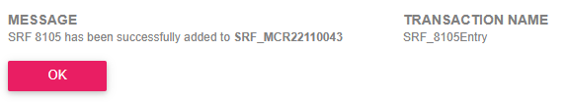

1. Repeat the process until the last item will close, delivered and liquidated.